Map Colouring
Here is a map:
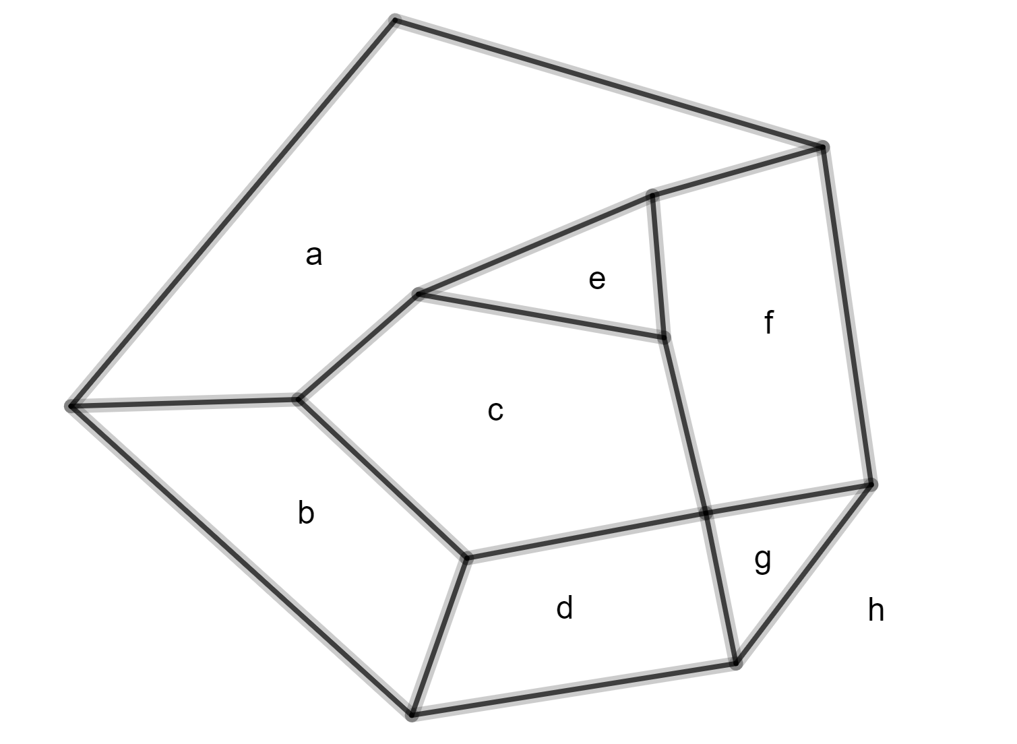

This map has 8 regionsWe want to colour the regions. Two regions that share a border likeandmust have different colours. Two regions that meet at a point likeandcan have the same colour. What is the minimum number of colours required?

Think of the regions as faces. Think of the borders as edges. Put a vertex where borders meet. We have a planar graph and we can use Euler’s formula.

Theorem
Every planar graph has a face with five (or fewer) edges.
Proof (by contradiction)
Assume there is a planar graph where every face has at least six edges.
Every face has at least six edges.
So:
No!
Each edge is shared by 2 faces.
So:
so
Every vertex has at least three edges.
So:
No!
Each edge is shared by two vertices.
So:
so
So:

So:
But, by Euler’s formula,
Contradiction

Six colour theorem
Every map can be coloured with at most six colours.
Proof
Say a map has 17 faces. We find a face with five (or fewer) edges.
The diagram below is just part of this map. Face B has five (or fewer) edges.

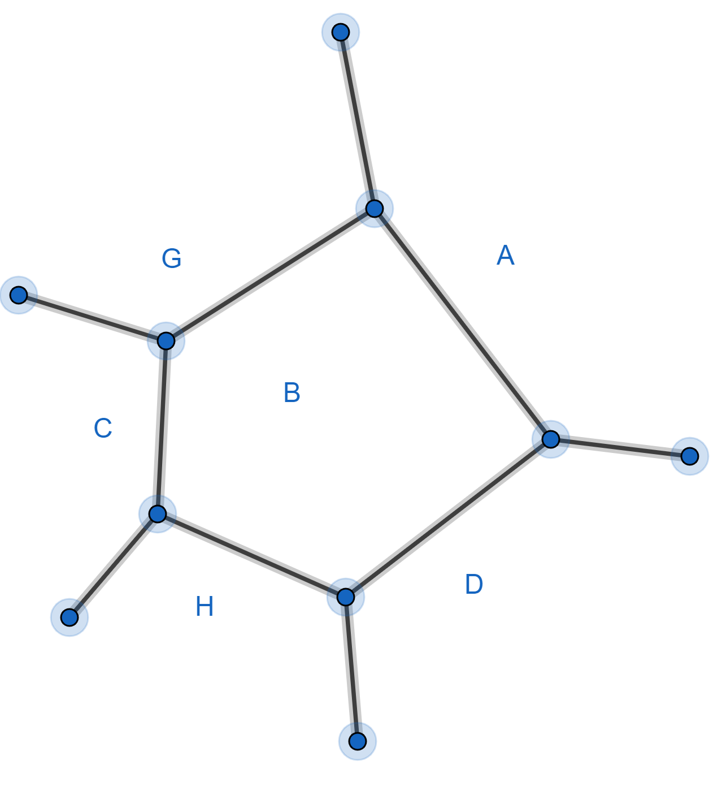

Remove this face in the following way:
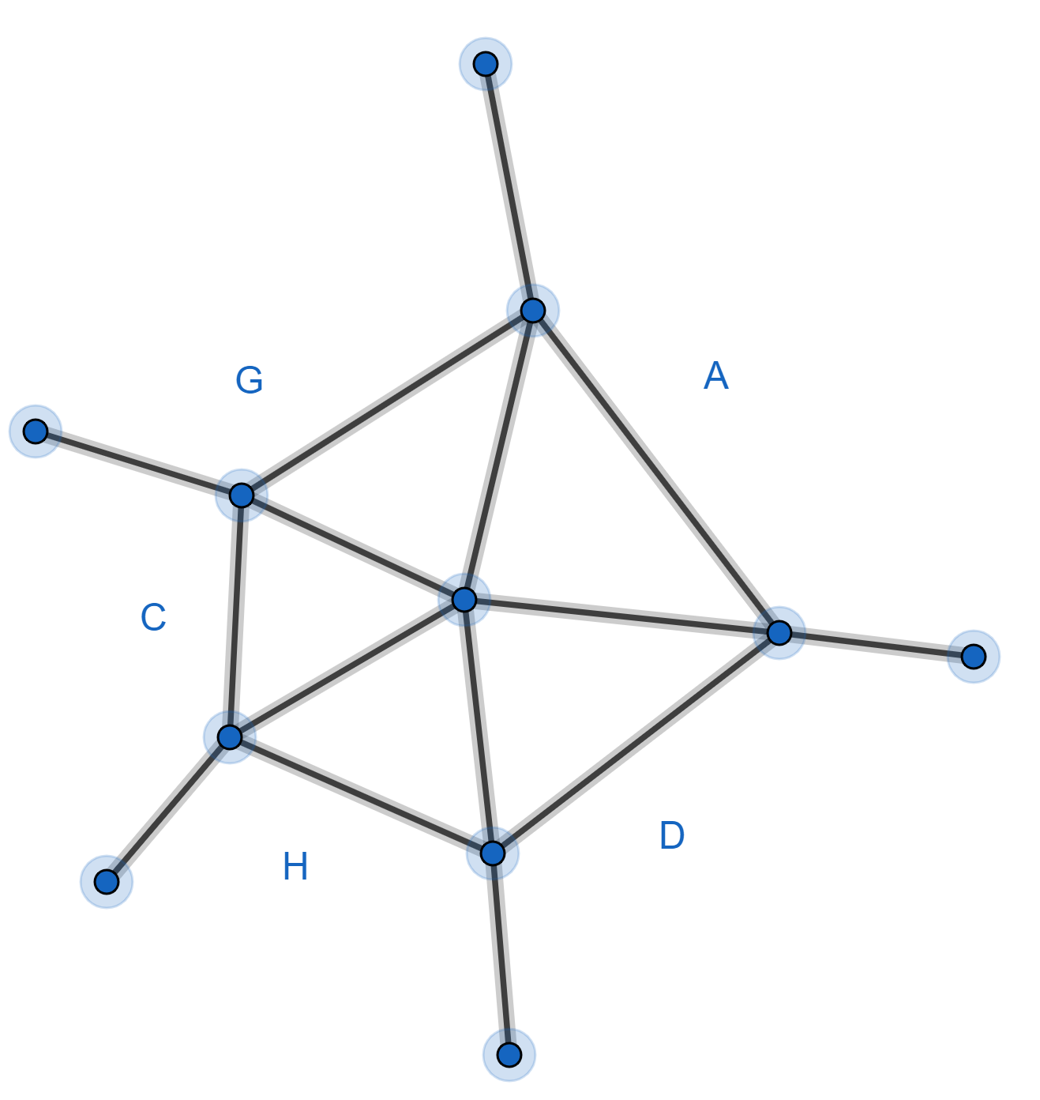
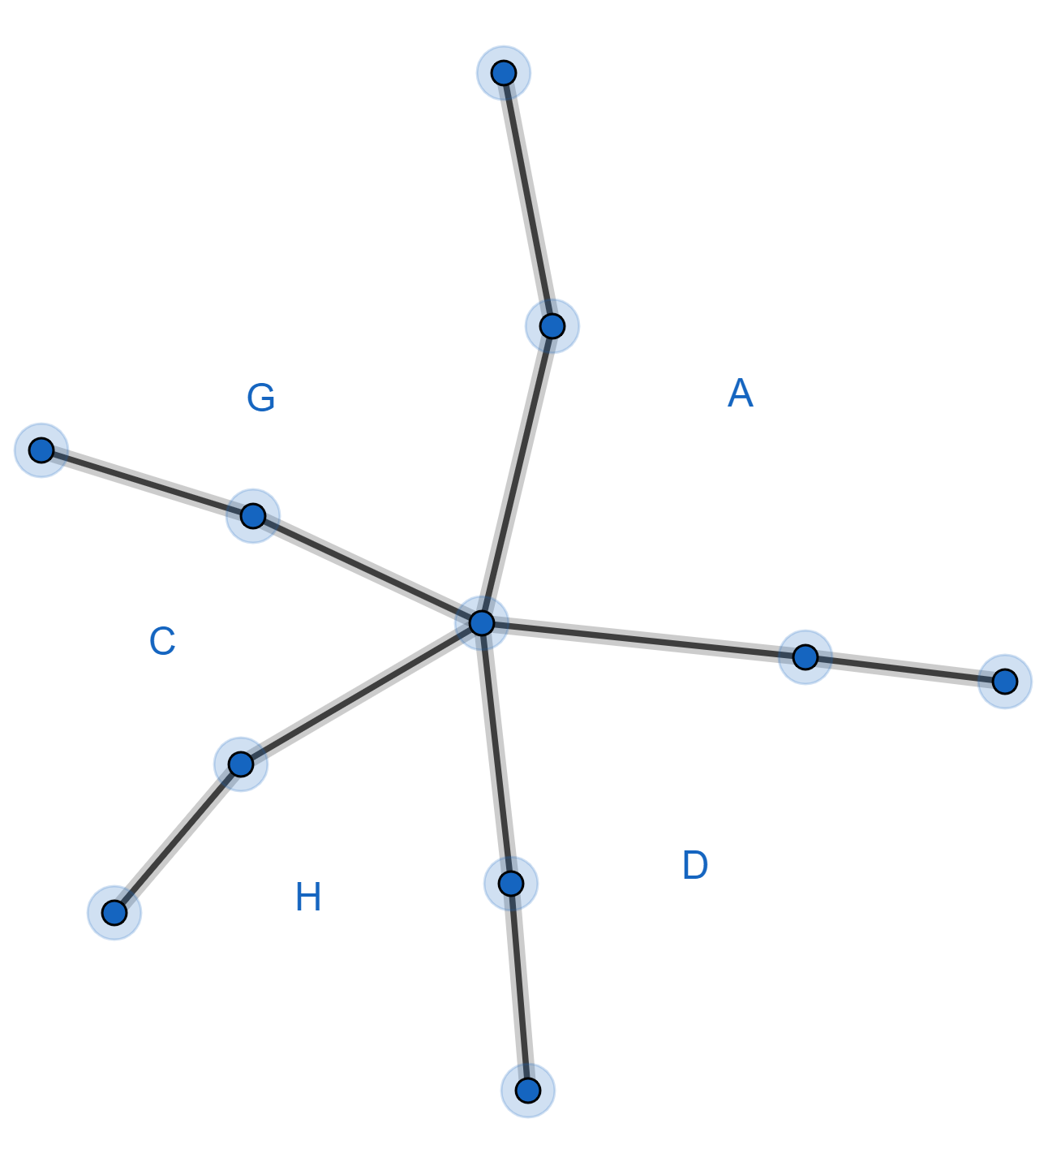

We now have a map with 16 faces. If we can colour the 16 face map with just six colours then we can colour the 17 face map with just six colours because we will only use five colours for the faces A, D, H, C, G and this leaves a sixth colour for when we reinstate face B.
We can now repeat the process.
We start with the 16 face map. We find a face with five (or fewer) edges.
We remove this face …
We start with the 15 face map ...
Eventually
We start with the 6 face map. We can colour this with six colours.
Then we go back and replace all the faces we have removed. Job done.

Four Colour Theorem
Every map can be coloured with at most four colours.
Proof
This was proved in 1976 by Appel and Haken. The proof is very difficult.

